|  |  |  |  |  |  |  |  |  |  |  |  |
| --- | --- | --- | --- | --- | --- | --- | --- | --- | --- | --- | --- |
| C:\Users\Eigenaar\Documents\PROVIL\Afbeeldingen - logo's\LOGO PROVIL ION 2.jpg | | | **Course: English**  **TEST: UNIT 3: Reading instructions** | | | | | | | | |
| **Teacher:** | | J. Boonen | | **Class** | | 3 WET/ECO | | **Date:** | | | 06/03/2017 |
| **Pupil:** | | Gijs Hoeben | | **Score:** | |  | | |  |  | |
|  | | | | | | | | | | | |
| **Selfevaluation** | | | | | | | | | | | |
| Before the test:  **While I studied, I…** | | | | | After the test has been corrected  **My results aren’t that well because…** | | | | | | |
| ☐ | Read the exercises; | | | | ☐ | | I did not read the questions well; | | | | |
| ☐ | did it orally; | | | | ☐ | | I did not understand the question; | | | | |
| ☐ | Wrote things down; | | | | ☐ | | I did not understand the curriculum that well; | | | | |
| ☐ | Prepared exercises while writing them down; | | | | ☐ | | I was sloppy; | | | | |
| ☐ | Made a test; | | | | ☐ | | I did not study well; | | | | |
| ☐ | Did not study that well; | | | | ☐ | | … | | | | |
| ☐ | Studied thoroughly; | | | |  | |  | | | | |
| ☐ | Prepared exercises we did not do in class; | | | |  | |  | | | | |
| ☐ |
| ☐ | … | | | |  | |  | | | | |
| I have studied for ________ min.  That is too much – a lot – enough – not that much – too little. | | | | | | | | | | | |
| I think I will score: ______ / ______ . | | | | | | | | | | | |
| **Tips:** | | | | | | | | | | | |
| ☐ |  | | | | | | | | | | |
| ☐ |  | | | | | | | | | | |
| ☐ |  | | | | | | | | | | |
| **Remedial exercises:** To understand the curriculum a bit better, you could:  Duedate: | | | | | | | | | | | |
| **Goals:** | | | | | | | | | | | |
| ☐ | You can read instructions. | | | | | | | | | | |
| ☐ |  | | | | | | | | | | |
| ☐ |  | | | | | | | | | | |

# 

# Extra shoelace hole

**First read the introductory article. Then add the numbers of the corresponding instructions to the pictures.**

**Wow, after all these years of tying trainers, we’ve finally found out what that extra shoelace hole at the top is for.**

It’s one of life’s little mysteries that we’d just learnt to deal with – until now, thanks to this illuminating video by the appropriately named Illumiseen.

The extra shoelace hole is actually for preventing blisters and for stopping your foot sliding around while you run.

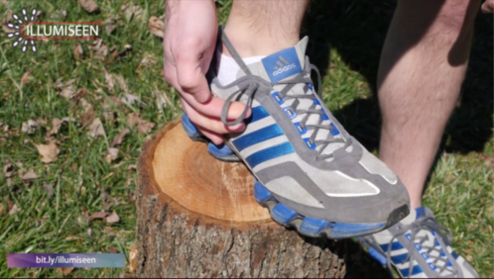

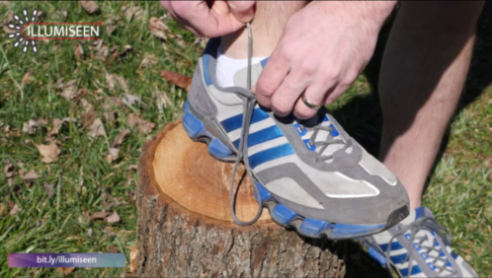

2

6

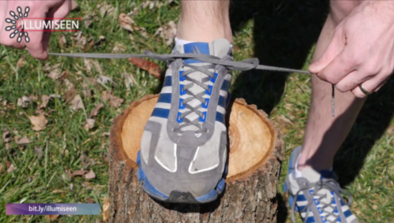

4

3

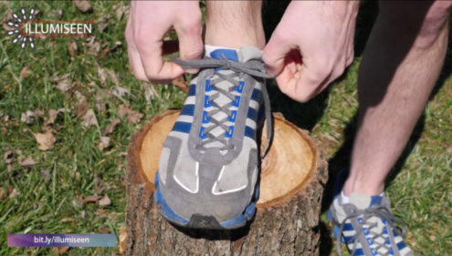

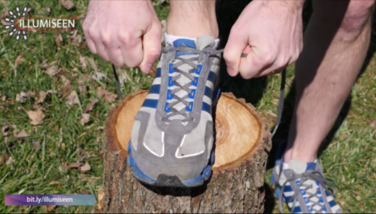

55

1

1. And then tie your laces like normal.
2. Make it snug like this.
3. On both sides, like this.
4. Then you cross the laces and pull.
5. Turns out they’re there for a reason.
6. You are supposed to slip you shoelaces through them.